Farhana Shaikh Sarvari

Date of Birth : 1st October 1993 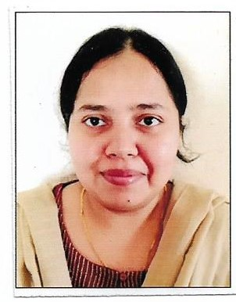
Gender : Female
Nationality : Indian
E mail id : farhanarhs@gmail.com
Address : Major Md Aasim, Qtr no 475
BEG Cantt , Roorkee.

Career Objective
To ease learning process for my students. To help students connect their subject knowledge with the current happenings for better understanding and cognition.

Academic Qualification
Class 10th / ICSE :Ryan International School ,Kharghar (year 2010) (secured 91 %)
Class 12th/ CBSE: Delhi Public School , Ghaziabad (year 2012) ( secured 86 %)
Graduation :Pune University , (year 2015) ( secured 78 %)
Post Graduation: IGNOU , (year 2021) (secured 67 %)

Qualified as Assistant Professor UGC NET 2020

Professional Skills :
- C++ , JAVA -Basic programming
- Good communication skills

Achievements
- Bagged 1st Prize at the State/Maharashtra level Essay Presentation on the Role of Cooperative Society and their challenges in a federal structure.
- State level Elocution competition winner.
- Cleared Rashtrabhasha Prarambhik Pariksha
- Merit holder in 1st Nationwide Biotechnology Olympiad
- Appointment letter offered for Civilian Academic Officer in Indian Military Academy, Dehradoon.
Work Experience
- Working in Methodist Girls PG College as Assistant Professor since May ,2022 teaching
- B.A students
- B.Sc students

Paper Presented /Published
- Paper titled ‘Right to be forgotten -Conflicting rights of Privacy and Freedom’ presented in February 2023 at National Seminar, Methodist Girls PG College,Roorkee.
Social Work
- Offering guidance to UPSC CSE aspirants on PSIR optional.

