RESUME
KHUSHBU GUPTA
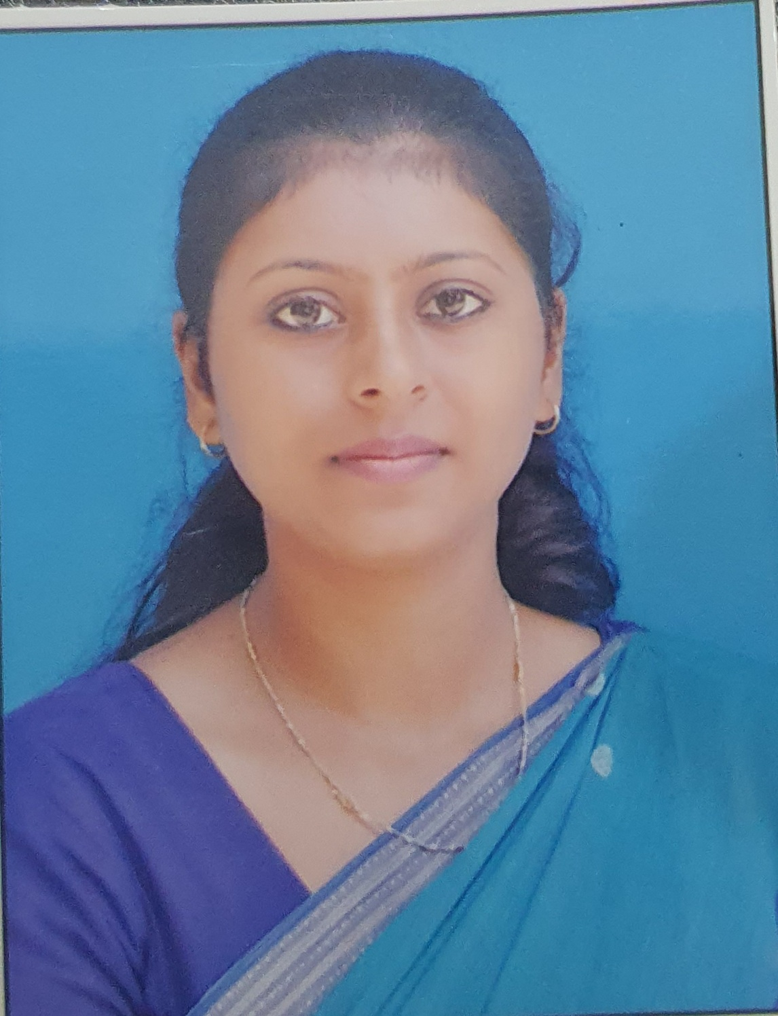
Contact No. : 8126747980
E.mail : khushbu207@rediffmail.com
H No. 711/85, Mathura vihar
Roorkee-247667

CAREER OBJECTIVE:
Intend to build a noble career with leading institutions of Hi-tech environment with committed and dedicated people, which will help me to explore myself fully and realize my potential willing to work as a key player in a challenging and creative environment.
Educational Qualification
Name of Examination | Year of passing | Board/University | Subject/Group | Percentage of Marks | Division
M.A. Eco  (Private) | BSM (PG) college, roorkee | Shri Dev Suman University | 2018 | 68% | first
M.Com  (Private) | BSM (PG) college, roorkee | Shri dev suman university | 2014 | 62% | first
B.ed | Sristhi institute of education, roorkee | HNB Garhwal university | 2015 | 79% | first
MBA  (gold medalist) | College of eng. roorkee | Uttarakhand technical university | 2013 | 80% | first
B.COM | Methodist girls degree college, roorkee | HNB Garhwal university | 2011 | 63% | first
Higher Secondary | ST’ Ann’s sr.sec.School, Roorkee | C.B.S.E | 2008 | 65% | first
Senior Secondary | ST’ Ann’s sr.sec.School, Roorkee | C.B.S.E | 2006 | 72% | first

WORK EXPERIENCE
Presently working as an Assistant Professor at Methodist Girls (PG) College, Roorkee (affiliated to H.N.B.Garhwal University, Srinagar) from 2013.

INDUSTRIAL TRAINING
Training atWIPRO LTD. Haridwar, project on “safety measures at WIPRO”.
SKILLS:

- MS Office, tally.

PROFILE OF EXPERIENCE
- International Webinar on “Post Covid Effects and Challenges on the Field of Education” on 7th & 8th July 2020 at Susana Methodist Girls B.Ed College.

- Attended International Webinar on “Pandemic Covid-19 and Survival of Indian MEMEs” on 28 June 2020 Glocal University, Saharanpur, U. P.
- Attended National Seminar “Vision India, Empowering Youth”on 19th March 2016 in Methodist Girls P.G. College Roorkee.

- Industrial visit in B.H.E.L. Ranipur, Haridwar.“Turbine Manufacturing & CNC Machines”

- Attended Workshop conducted by “Security Exchange Board Of India”,on “Financial Planning/ Financial Awareness” heldin COER, Roorkee.
- Attended workshop on “research and development in institutions challenging and its perspective in industry” conducted by COER, Roorkee.
- Received A+ grade certificate in a three month course in tally from a recognized institute.

Workshop
“Refine your Data Analysis Skills: An Application of SPSS”. COER GROUP OF INSTITUTION. 2021.

RESEARCH GUIDANCE
Guided more than 40 students of M.com final year under different research projects.

CO-CURRICULAR ACTIVITIES

Participated and got prizes in different co-curricular activities such as debate, general awareness quiz,power point presentation etc.

PERSONAL INFORMATION PROFILE:

FATHERS NAME : Mr. N.K GUPTA
MOTHERS NAME : Mrs. KUSUM GUPTA
DATE OF BIRTH : 20/07/1989
PERMANENT ADDRESS : H No. 711/85, Mathura vihar
Roorkee
Dist; haridwar (247667)
DECLARATION:
I hereby declare that the information furnished above is true to best of my knowledge.
SIGNATURE: Khushbu Gupta

